**.com.task.utility:-**

**.ConnectionPool:**

/*

* To change this license header, choose License Headers in Project Properties.

* To change this template file, choose Tools | Templates

* and open the template in the editor.

*/

package com.task.utility;

import java.sql.*;

import java.util.logging.Level;

import java.util.logging.Logger;

/**

*

* @author manis

*/

public class ConnectionPool {

static Connection conn;

public static Connection connectDB() {

try {

//Step1: Register the Driver

Class.forName("com.mysql.cj.jdbc.Driver");

// Step2: Create the connection

String url = "jdbc:mysql://localhost:3306/empdb";

String userName = "root";

String password = "Manish@2163";

conn = DriverManager.getConnection(url,userName, password);

System.out.println("Database Connection Success");

} catch (ClassNotFoundException ex) {

Logger.getLogger(ConnectionPool.class.getName()).log(Level.SEVERE, null, ex);

} catch (SQLException ex) {

Logger.getLogger(ConnectionPool.class.getName()).log(Level.SEVERE, null, ex);

}

return conn;

}

public static void main(String[] args) {

connectDB();

}

}

**.UserBean:**

/*

* To change this license header, choose License Headers in Project Properties.

* To change this template file, choose Tools | Templates

* and open the template in the editor.

*/

package com.task.bean;

/**

*

* @author manis

*/

public class UsersBean {

private int uid;

private String name;

private String username;

private String password;

private String email;

private String mobile;

public UsersBean() {

}

public UsersBean(int uid, String name, String username, String password, String email, String mobile) {

this.uid = uid;

this.name = name;

this.username = username;

this.password = password;

this.email = email;

this.mobile = mobile;

}

public int getUid() {

return uid;

}

public void setUid(int uid) {

this.uid = uid;

}

public String getName() {

return name;

}

public void setName(String name) {

this.name = name;

}

public String getUsername() {

return username;

}

public void setUsername(String username) {

this.username = username;

}

public String getPassword() {

return password;

}

public void setPassword(String password) {

this.password = password;

}

public String getEmail() {

return email;

}

public void setEmail(String email) {

this.email = email;

}

public String getMobile() {

return mobile;

}

public void setMobile(String mobile) {

this.mobile = mobile;

}

}

**.UsersDAO**

1. **Register user**

/*

* To change this license header, choose License Headers in Project Properties.

* To change this template file, choose Tools | Templates

* and open the template in the editor.

*/

package com.task.dao;

import com.task.bean.UsersBean;

import com.task.utility.ConnectionPool;

import java.sql.Connection;

import java.sql.ResultSet;

import java.sql.SQLException;

import java.sql.Statement;

import java.util.logging.Level;

import java.util.logging.Logger;

/**

*

* @author manis

*/

public class UsersDAO {

static Connection conn;

public int registerUser(UsersBean ub) {

int r =0;

//Step1:

//Step2:

conn = ConnectionPool.connectDB();

//Step3: write sql query

String sql = "insert into users values('"+ub.getUid()+"','"+ub.getName()+"','"+ub.getUsername()+"','"+ub.getPassword()+"','"+ub.getEmail()+"','"+ub.getMobile()+"' )";

try {

//Step4: create object of statement

Statement stmt = conn.createStatement();

//step5: call executUpdate

r = stmt.executeUpdate(sql);

//step6: close the connection

conn.close();

} catch (SQLException ex) {

Logger.getLogger(UsersDAO.class.getName()).log(Level.SEVERE, null, ex);

}

return r;

}

public static void main(String[] args) {

//call the register

UsersBean ub = new UsersBean();

ub.setUid(101);

ub.setName("Manish");

ub.setUsername("Manish2163");

ub.setPassword("12345");

ub.setEmail("manishroy2163@gmail.com");

ub.setMobile("6206743012");

UsersDAO ud = new UsersDAO();

int r = ud.registerUser(ub);

if(r>0){

System.out.println("Registration success");

}else{

System.out.println("Registration fail");

}

}

}

**.output:**

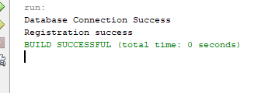

1. **LoginUser:**

/*

* To change this license header, choose License Headers in Project Properties.

* To change this template file, choose Tools | Templates

* and open the template in the editor.

*/

package com.task.dao;

import com.task.bean.UsersBean;

import com.task.utility.ConnectionPool;

import java.sql.Connection;

import java.sql.ResultSet;

import java.sql.SQLException;

import java.sql.Statement;

import java.util.logging.Level;

import java.util.logging.Logger;

/**

*

* @author manis

*/

public class UsersDAO {

static Connection conn;

public int loginCheck(String userName, String password) throws SQLException{

int id =0;

conn=ConnectionPool.connectDB();

String sql = "select uid from users where username='"+userName+"'and password='"+password+"'";

try {

Statement stmt = conn.createStatement();

ResultSet rs = stmt.executeQuery(sql);

if(rs.next()){

id = rs.getInt("uid");

}

conn.close();

} catch (SQLException ex) {

Logger.getLogger(UsersDAO.class.getName()).log(Level.SEVERE, null, ex);

}

return id;

}

public static void main(String[] args) throws SQLException {

//call registerUser()

UsersDAO ud = new UsersDAO();

int r = ud.loginCheck("Manish2163", "12345");

if(r>0){

System.out.println("Login Success");

}else{

System.out.println("Login fail");

}

}

}

**.Output:**

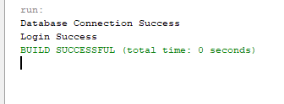

**.empBean:**

/*

* To change this license header, choose License Headers in Project Properties.

* To change this template file, choose Tools | Templates

* and open the template in the editor.

*/

package com.task.bean;

/**

*

* @author manis

*/

public class EmpBean {

private int empno;

private String ename;

private String job;

private int mgr;

private String hiredate;

private float sal ;

private float comm;

private int deptno;

//member data

public EmpBean() {

}

public EmpBean(int empno, String ename, String job, int mgr, String hiredate, float sal, float comm, int deptno) {

this.empno = empno;

this.ename = ename;

this.job = job;

this.mgr = mgr;

this.hiredate = hiredate;

this.sal = sal;

this.comm = comm;

this.deptno = deptno;

}

public int getEmpno() {

return empno;

}

public void setEmpno(int empno) {

this.empno = empno;

}

public String getEname() {

return ename;

}

public void setEname(String ename) {

this.ename = ename;

}

public String getJob() {

return job;

}

public void setJob(String job) {

this.job = job;

}

public int getMgr() {

return mgr;

}

public void setMgr(int mgr) {

this.mgr = mgr;

}

public String getHiredate() {

return hiredate;

}

public void setHiredate(String hiredate) {

this.hiredate = hiredate;

}

public float getSal() {

return sal;

}

public void setSal(float sal) {

this.sal = sal;

}

public float getComm() {

return comm;

}

public void setComm(float comm) {

this.comm = comm;

}

public int getDeptno() {

return deptno;

}

public void setDeptno(int deptno) {

this.deptno = deptno;

}

}

.empDAO:-

1. **Add Employee**

/*

* To change this license header, choose License Headers in Project Properties.

* To change this template file, choose Tools | Templates

* and open the template in the editor.

*/

package com.task.dao;

import com.task.bean.EmpBean;

import com.task.utility.ConnectionPool;

import java.sql.Connection;

import java.sql.SQLException;

import java.sql.Statement;

import java.util.logging.Level;

import java.util.logging.Logger;

/**

*

* @author manis

*/

public class EmpDAo {

static Connection conn;

public int addEmp(EmpBean eb){

int r =0;

//Step1:

//step2:

conn = ConnectionPool.connectDB();

//step3:Write sql query

String sql ="insert into emp values('"+eb.getEmpno()+"','"+eb.getEname()+"','"+eb.getJob()+"','"+eb.getMgr()+"','"+eb.getSal()+"','"+eb.getComm()+"','"+eb.getDeptno()+"','"+eb.getHiredate()+"')";

try {

//step4: Create object of statement

Statement stmt = conn.createStatement();

//step5: call executeUpdate()

r = stmt.executeUpdate(sql);

//step6: close the connection

conn.close();

} catch (SQLException ex) {

Logger.getLogger(EmpDAo.class.getName()).log(Level.SEVERE, null, ex);

}

return r;

}

public static void main(String[] args) {

EmpBean eb = new EmpBean();

eb.setEmpno(1111);

eb.setEname("manish");

eb.setJob("MANAGER");

eb.setMgr(123);

eb.setHiredate("05-04-2022");

eb.setSal(10000);

eb.setComm(800);

eb.setDeptno(20);

EmpDAo ed = new EmpDAo();

int result = ed.addEmp(eb);

if(result>0){

System.out.println("Employee added success");

}else{

System.out.println("Employee not added");

}

}

}

**.Output:**

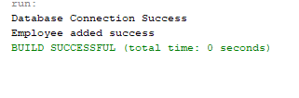

1. **Update Employee:**

/*

* To change this license header, choose License Headers in Project Properties.

* To change this template file, choose Tools | Templates

* and open the template in the editor.

*/

package com.task.dao;

import com.task.bean.EmpBean;

import com.task.utility.ConnectionPool;

import java.sql.Connection;

import java.sql.SQLException;

import java.sql.Statement;

import java.util.logging.Level;

import java.util.logging.Logger;

/**

*

* @author manis

*/

public class EmpDAo {

static Connection conn;

public int UpdateEmp(EmpBean eb){

int r =0;

//step1:

//step2:

conn = ConnectionPool.connectDB();

//Step3: write sql query

String sql = "update emp set ename='"+eb.getEname()+"',job='"+eb.getJob()+"',mgr='"+eb.getMgr()+"',sal='"+eb.getSal()+"',comm='"+eb.getComm()+"',deptno='"+eb.getDeptno()+"',hiredate='"+eb.getHiredate()+"' where empno='"+eb.getEmpno()+"'";

try {

//step4: create object of statement

Statement stmt = conn.createStatement();

//Step5: call execute Update()

r = stmt.executeUpdate(sql);

//Step6: close the connection

conn.close();

} catch (SQLException ex) {

Logger.getLogger(EmpDAo.class.getName()).log(Level.SEVERE, null, ex);

}

return r;

}

public static void main(String[] args) {

EmpBean eb = new EmpBean();

eb.setEname("Manish kumar");

eb.setComm(900);

eb.setDeptno(10);

eb.setHiredate("02-01-2025");

eb.setJob("MANAGER");

eb.setMgr(12345);

eb.setEmpno(1111);

EmpDAo ed = new EmpDAo();

int result = ed.UpdateEmp(eb);

if(result>0){

System.out.println("Employee Update success");

}else{

System.out.println("Employee not updated");

}

}

}

**.Output:**

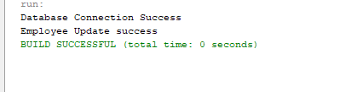

**3.Delete Employee:**

/*

* To change this license header, choose License Headers in Project Properties.

* To change this template file, choose Tools | Templates

* and open the template in the editor.

*/

package com.task.dao;

import com.task.bean.EmpBean;

import com.task.utility.ConnectionPool;

import java.sql.Connection;

import java.sql.SQLException;

import java.sql.Statement;

import java.util.logging.Level;

import java.util.logging.Logger;

/**

*

* @author manis

*/

public class EmpDAo {

static Connection conn;

public int deleteEmp(int empno){

int r =0;

//step1;

//step2:

conn = ConnectionPool.connectDB();

//Step3: write sql query

String sql = "delete from emp where empno='"+empno+"'";

try {

//Step4: create object of statement ;

Statement stmt = conn.createStatement();

// Step5: call executeUpdate();

r = stmt.executeUpdate(sql);

//step6: close the connection

conn.close();

} catch (SQLException ex) {

Logger.getLogger(EmpDAo.class.getName()).log(Level.SEVERE, null, ex);

}

return r;

}

public static void main(String[] args) {

//call deletEmp();

EmpDAo ed = new EmpDAo();

int x = ed.deleteEmp(1111);

if(x>0){

System.out.println("Data deletion success");

}else{

System.out.println("Data deletion fail");

}

}

}

**.Output:**

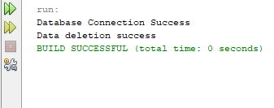

**3.Find All**

/*

* To change this license header, choose License Headers in Project Properties.

* To change this template file, choose Tools | Templates

* and open the template in the editor.

*/

package com.task.dao;

import com.task.bean.EmpBean;

import com.task.utility.ConnectionPool;

import java.sql.Connection;

import java.sql.ResultSet;

import java.sql.SQLException;

import java.sql.Statement;

import java.util.ArrayList;

import java.util.logging.Level;

import java.util.logging.Logger;

/**

*

* @author manis

*/

public class EmpDAo {

static Connection conn;

public ArrayList<EmpBean> findAll(){

//step1:

//step2:

conn = ConnectionPool.connectDB();

ArrayList<EmpBean> list = new ArrayList<EmpBean>();

//step3: write sql query select

String sql = "select * from Emp";

try {

//step4: Create an object of statement

Statement stmt = conn.createStatement();

//step5: Call executeQuery method

ResultSet rs = stmt.executeQuery(sql);

//step6: Extract data from the ResultSet and add into ArrayList

while(rs.next()){

EmpBean x = new EmpBean();

//step1: Fetch data from resultSet and Set into the bean

x.setEmpno(rs.getInt("Empno"));

x.setEname(rs.getString("Ename"));

x.setJob(rs.getString("job"));

x.setMgr(rs.getInt("mgr"));

x.setSal(rs.getFloat("sal"));

x.setComm(rs.getFloat("comm"));

x.setDeptno(rs.getInt("deptno"));

x.setHiredate(rs.getString("hiredate"));

//step2: add bean object into list

list.add(x);

}

//step7: Close the connection

conn.close();

} catch (SQLException ex) {

Logger.getLogger(EmpDAo.class.getName()).log(Level.SEVERE, null, ex);

}

return list;

}

public static void main(String[] args) {

//call findAll Method

EmpDAo ed = new EmpDAo();

ArrayList<EmpBean> al = ed.findAll();

for(EmpBean e : al){

System.out.println("\t"+e.getEmpno()+"\t"+e.getEname()+"\t"+e.getJob()+"\t"+e.getMgr()+"\t"+e.getSal()+"\t"+e.getComm()+"\t"+e.getDeptno()+"\t"+e.getHiredate());

}

}

}

**Output:**

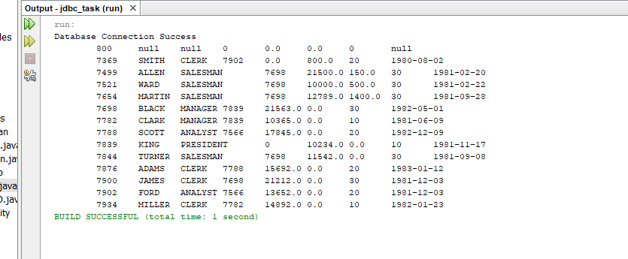

1. **findByEmpno:**

/*

* To change this license header, choose License Headers in Project Properties.

* To change this template file, choose Tools | Templates

* and open the template in the editor.

*/

package com.task.dao;

import com.task.bean.EmpBean;

import com.task.utility.ConnectionPool;

import java.sql.Connection;

import java.sql.ResultSet;

import java.sql.SQLException;

import java.sql.Statement;

import java.util.ArrayList;

import java.util.logging.Level;

import java.util.logging.Logger;

/**

*

* @author manis

*/

public class EmpDAo {

static Connection conn;

public EmpBean findByEmpno(int empno){

EmpBean x = new EmpBean();

conn = ConnectionPool.connectDB();

//step3: Write sql query

String sql = "select * from emp where empno='"+empno+"'";

try {

//step4: create object Statement

Statement stmt = conn.createStatement();

//step5: call execute Query

ResultSet rs = stmt.executeQuery(sql);

while(rs.next()){

//stepA: create an object of EmpBean

//StepB: Fetch data from ResultSet and set into empBean object

x.setEmpno(rs.getInt("Empno"));

x.setEname(rs.getString("Ename"));

x.setJob(rs.getString("job"));

x.setMgr(rs.getInt("mgr"));

x.setSal(rs.getFloat("sal"));

x.setComm(rs.getFloat("comm"));

x.setDeptno(rs.getInt("deptno"));

x.setHiredate(rs.getString("hiredate"));

}

conn.close();

} catch (SQLException ex) {

Logger.getLogger(EmpDAo.class.getName()).log(Level.SEVERE, null, ex);

}

return x;

}

public static void main(String[] args) {

//5.call findById()

EmpDAo ed = new EmpDAo();

EmpBean eb = ed.findByEmpno(7369);

System.out.println("\t"+eb.getEmpno()+"\t"+eb.getEname()+"\t"+eb.getJob()+"\t"+eb.getMgr()+"\t"+eb.getSal()+"\t"+eb.getComm()+"\t"+eb.getDeptno()+"\t"+eb.getHiredate());

}

}

**.Output:**

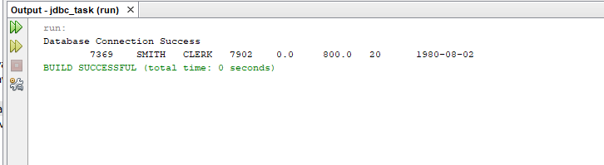

1. **findAllByDeptno:**

/*

* To change this license header, choose License Headers in Project Properties.

* To change this template file, choose Tools | Templates

* and open the template in the editor.

*/

package com.task.dao;

import com.task.bean.EmpBean;

import com.task.utility.ConnectionPool;

import java.sql.Connection;

import java.sql.ResultSet;

import java.sql.SQLException;

import java.sql.Statement;

import java.util.ArrayList;

import java.util.logging.Level;

import java.util.logging.Logger;

/**

*

* @author manis

*/

public class EmpDAo {

static Connection conn;

public ArrayList<EmpBean> findAllByDeptno(int deptno){

//step1:

//step2:

conn = ConnectionPool.connectDB();

ArrayList<EmpBean> list = new ArrayList<EmpBean>();

//step3: write sql query select

String sql = "select * from Emp where Deptno='"+deptno+"'";

try {

//step4: Create an object of statement

Statement stmt = conn.createStatement();

//step5: Call executeQuery method

ResultSet rs = stmt.executeQuery(sql);

//step6: Extract data from the ResultSet and add into ArrayList

while(rs.next()){

EmpBean x = new EmpBean();

//step1: Fetch data from resultSet and Set into the bean

x.setEmpno(rs.getInt("Empno"));

x.setEname(rs.getString("Ename"));

x.setJob(rs.getString("job"));

x.setMgr(rs.getInt("mgr"));

x.setSal(rs.getFloat("sal"));

x.setComm(rs.getFloat("comm"));

x.setDeptno(rs.getInt("deptno"));

x.setHiredate(rs.getString("hiredate"));

//step2: add bean object into list

list.add(x);

}

//step7: Close the connection

conn.close();

} catch (SQLException ex) {

Logger.getLogger(EmpDAo.class.getName()).log(Level.SEVERE, null, ex);

}

return list;

}

public static void main(String[] args) {

//call findAll Method

EmpDAo ed = new EmpDAo();

ArrayList<EmpBean> al = ed.findAllByDeptno(20);

for(EmpBean e : al){

System.out.println("\t"+e.getEmpno()+"\t"+e.getEname()+"\t"+e.getJob()+"\t"+e.getMgr()+"\t"+e.getSal()+"\t"+e.getComm()+"\t"+e.getDeptno()+"\t"+e.getHiredate());

}

}

}

**.Output:**

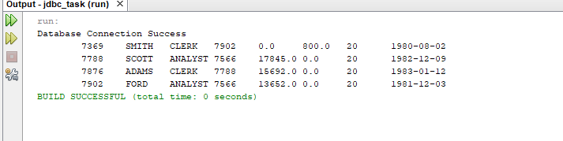

1. **findByJob:**

/*

* To change this license header, choose License Headers in Project Properties.

* To change this template file, choose Tools | Templates

* and open the template in the editor.

*/

package com.task.dao;

import com.task.bean.EmpBean;

import com.task.utility.ConnectionPool;

import java.sql.Connection;

import java.sql.ResultSet;

import java.sql.SQLException;

import java.sql.Statement;

import java.util.ArrayList;

import java.util.logging.Level;

import java.util.logging.Logger;

/**

*

* @author manis

*/

public class EmpDAo {

static Connection conn;

public ArrayList<EmpBean> findByJob(String job){

//step1:

//step2:

conn = ConnectionPool.connectDB();

ArrayList<EmpBean> list = new ArrayList<EmpBean>();

//step3: write sql query select

String sql = "select * from Emp where Job='"+job+"'";

try {

//step4: Create an object of statement

Statement stmt = conn.createStatement();

//step5: Call executeQuery method

ResultSet rs = stmt.executeQuery(sql);

//step6: Extract data from the ResultSet and add into ArrayList

while(rs.next()){

EmpBean x = new EmpBean();

//step1: Fetch data from resultSet and Set into the bean

x.setEmpno(rs.getInt("Empno"));

x.setEname(rs.getString("Ename"));

x.setJob(rs.getString("job"));

x.setMgr(rs.getInt("mgr"));

x.setSal(rs.getFloat("sal"));

x.setComm(rs.getFloat("comm"));

x.setDeptno(rs.getInt("deptno"));

x.setHiredate(rs.getString("hiredate"));

//step2: add bean object into list

list.add(x);

}

//step7: Close the connection

conn.close();

} catch (SQLException ex) {

Logger.getLogger(EmpDAo.class.getName()).log(Level.SEVERE, null, ex);

}

return list;

}

public static void main(String[] args) {

//call findAll Method

EmpDAo ed = new EmpDAo();

ArrayList<EmpBean> al = ed.findByJob("CLERK");

for(EmpBean e : al){

System.out.println("\t"+e.getEmpno()+"\t"+e.getEname()+"\t"+e.getJob()+"\t"+e.getMgr()+"\t"+e.getSal()+"\t"+e.getComm()+"\t"+e.getDeptno()+"\t"+e.getHiredate());

}

}

}

**.Output:**

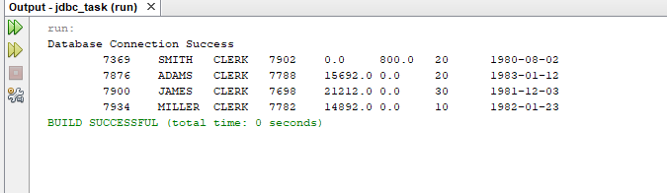

1. **sortEmployeeAsciendingOrder(float sal):**

/*

* To change this license header, choose License Headers in Project Properties.

* To change this template file, choose Tools | Templates

* and open the template in the editor.

*/

package com.task.dao;

import com.task.bean.EmpBean;

import com.task.utility.ConnectionPool;

import java.sql.Connection;

import java.sql.ResultSet;

import java.sql.SQLException;

import java.sql.Statement;

import java.util.ArrayList;

import java.util.logging.Level;

import java.util.logging.Logger;

/**

*

* @author manis

*/

public class EmpDAo {

static Connection conn;

private static float sal;

public ArrayList<EmpBean> sortEmployeeAsceindingOrder(float sal){

//step1:

//step2:

conn = ConnectionPool.connectDB();

ArrayList<EmpBean> list = new ArrayList<EmpBean>();

//step3: write sql query select

String sql = "select * from Emp order by sal asc";

try {

//step4: Create an object of statement

Statement stmt = conn.createStatement();

//step5: Call executeQuery method

ResultSet rs = stmt.executeQuery(sql);

//step6: Extract data from the ResultSet and add into ArrayList

while(rs.next()){

EmpBean x = new EmpBean();

//step1: Fetch data from resultSet and Set into the bean

x.setEmpno(rs.getInt("Empno"));

x.setEname(rs.getString("Ename"));

x.setJob(rs.getString("job"));

x.setMgr(rs.getInt("mgr"));

x.setSal(rs.getFloat("sal"));

x.setComm(rs.getFloat("comm"));

x.setDeptno(rs.getInt("deptno"));

x.setHiredate(rs.getString("hiredate"));

//step2: add bean object into list

list.add(x);

}

//step7: Close the connection

conn.close();

} catch (SQLException ex) {

Logger.getLogger(EmpDAo.class.getName()).log(Level.SEVERE, null, ex);

}

return list;

}

public static void main(String[] args) {

//call findAll Method

EmpDAo ed = new EmpDAo();

ArrayList<EmpBean> al = ed.sortEmployeeAsceindingOrder(sal);

for(EmpBean e : al){

System.out.println("\t"+e.getEmpno()+"\t"+e.getEname()+"\t"+e.getJob()+"\t"+e.getMgr()+"\t"+e.getSal()+"\t"+e.getComm()+"\t"+e.getDeptno()+"\t"+e.getHiredate());

}

}

}

**.Output:**

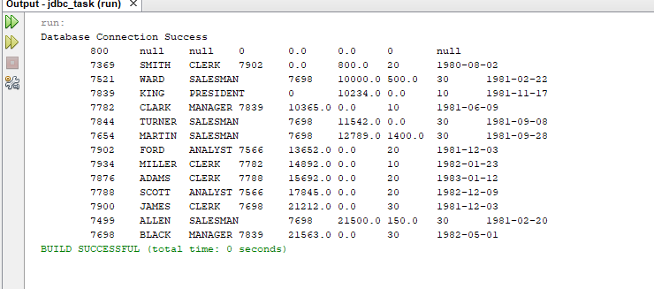

1. **sortEmployeeAsciendingOrder(String ename):**

/*

* To change this license header, choose License Headers in Project Properties.

* To change this template file, choose Tools | Templates

* and open the template in the editor.

*/

package com.task.dao;

import com.task.bean.EmpBean;

import com.task.utility.ConnectionPool;

import java.sql.Connection;

import java.sql.ResultSet;

import java.sql.SQLException;

import java.sql.Statement;

import java.util.ArrayList;

import java.util.logging.Level;

import java.util.logging.Logger;

/**

*

* @author manis

*/

public class EmpDAo {

static Connection conn;

private static String ename;

public ArrayList<EmpBean> sortEmployeeAsceindingOrder(String ename){

//step1:

//step2:

conn = ConnectionPool.connectDB();

ArrayList<EmpBean> list = new ArrayList<EmpBean>();

//step3: write sql query select

String sql = "select * from Emp order by ename asc";

try {

//step4: Create an object of statement

Statement stmt = conn.createStatement();

//step5: Call executeQuery method

ResultSet rs = stmt.executeQuery(sql);

//step6: Extract data from the ResultSet and add into ArrayList

while(rs.next()){

EmpBean x = new EmpBean();

//step1: Fetch data from resultSet and Set into the bean

x.setEmpno(rs.getInt("Empno"));

x.setEname(rs.getString("Ename"));

x.setJob(rs.getString("job"));

x.setMgr(rs.getInt("mgr"));

x.setSal(rs.getFloat("sal"));

x.setComm(rs.getFloat("comm"));

x.setDeptno(rs.getInt("deptno"));

x.setHiredate(rs.getString("hiredate"));

//step2: add bean object into list

list.add(x);

}

//step7: Close the connection

conn.close();

} catch (SQLException ex) {

Logger.getLogger(EmpDAo.class.getName()).log(Level.SEVERE, null, ex);

}

return list;

}

public static void main(String[] args) {

//call findAll Method

EmpDAo ed = new EmpDAo();

ArrayList<EmpBean> al = ed.sortEmployeeAsceindingOrder(ename);

for(EmpBean e : al){

System.out.println("\t"+e.getEmpno()+"\t"+e.getEname()+"\t"+e.getJob()+"\t"+e.getMgr()+"\t"+e.getSal()+"\t"+e.getComm()+"\t"+e.getDeptno()+"\t"+e.getHiredate());

}

}

}

**.Output:**

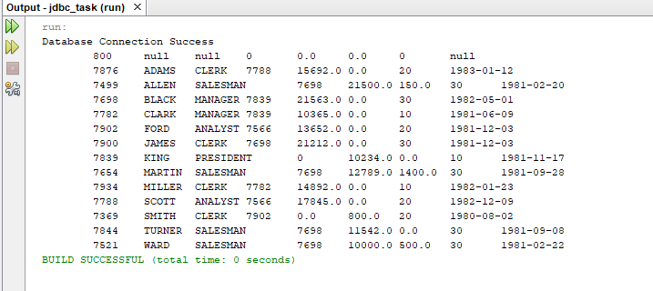

1. **sortEmployeeDescendingOrder(float sal):**

/*

* To change this license header, choose License Headers in Project Properties.

* To change this template file, choose Tools | Templates

* and open the template in the editor.

*/

package com.task.dao;

import com.task.bean.EmpBean;

import com.task.utility.ConnectionPool;

import java.sql.Connection;

import java.sql.ResultSet;

import java.sql.SQLException;

import java.sql.Statement;

import java.util.ArrayList;

import java.util.logging.Level;

import java.util.logging.Logger;

/**

*

* @author manis

*/

public class EmpDAo {

static Connection conn;

private static float sal;

public ArrayList<EmpBean> sortEmployeeDescendingOrder(float sal){

//step1:

//step2:

conn = ConnectionPool.connectDB();

ArrayList<EmpBean> list = new ArrayList<EmpBean>();

//step3: write sql query select

String sql = "select * from Emp order by sal desc";

try {

//step4: Create an object of statement

Statement stmt = conn.createStatement();

//step5: Call executeQuery method

ResultSet rs = stmt.executeQuery(sql);

//step6: Extract data from the ResultSet and add into ArrayList

while(rs.next()){

EmpBean x = new EmpBean();

//step1: Fetch data from resultSet and Set into the bean

x.setEmpno(rs.getInt("Empno"));

x.setEname(rs.getString("Ename"));

x.setJob(rs.getString("job"));

x.setMgr(rs.getInt("mgr"));

x.setSal(rs.getFloat("sal"));

x.setComm(rs.getFloat("comm"));

x.setDeptno(rs.getInt("deptno"));

x.setHiredate(rs.getString("hiredate"));

//step2: add bean object into list

list.add(x);

}

//step7: Close the connection

conn.close();

} catch (SQLException ex) {

Logger.getLogger(EmpDAo.class.getName()).log(Level.SEVERE, null, ex);

}

return list;

}

public static void main(String[] args) {

//call findAll Method

EmpDAo ed = new EmpDAo();

ArrayList<EmpBean> al = ed.sortEmployeeDescendingOrder(sal);

for(EmpBean e : al){

System.out.println("\t"+e.getEmpno()+"\t"+e.getEname()+"\t"+e.getJob()+"\t"+e.getMgr()+"\t"+e.getSal()+"\t"+e.getComm()+"\t"+e.getDeptno()+"\t"+e.getHiredate());

}

}

}

**.Output:**

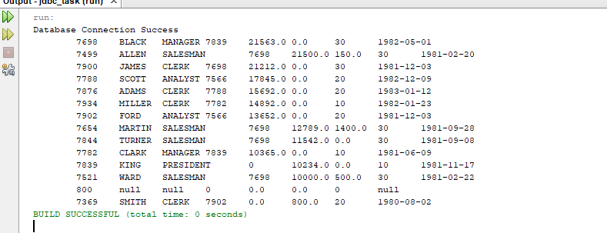

1. **sumSalary:**

/*

* To change this license header, choose License Headers in Project Properties.

* To change this template file, choose Tools | Templates

* and open the template in the editor.

*/

package com.task.dao;

import com.task.bean.EmpBean;

import com.task.utility.ConnectionPool;

import java.sql.Connection;

import java.sql.ResultSet;

import java.sql.SQLException;

import java.sql.Statement;

import java.util.ArrayList;

import java.util.logging.Level;

import java.util.logging.Logger;

/**

*

* @author manis

*/

public class EmpDAo {

static Connection conn;

public double SumSalary() {

conn = ConnectionPool.connectDB();

float totalSalary = 0;

String sql = "SELECT SUM(sal) AS total FROM emp";

try {

Statement stmt = conn.createStatement();

ResultSet rs = stmt.executeQuery(sql);

if (rs.next()) {

totalSalary = rs.getFloat("total"); // Fetch sum(sal)

}

conn.close();

} catch (SQLException ex) {

Logger.getLogger(EmpDAo.class.getName()).log(Level.SEVERE, null, ex);

}

return totalSalary;

}

public static void main(String[] args) {

EmpDAo ed = new EmpDAo();

double totalSal = ed.SumSalary();

System.out.println("Total Salary: " + totalSal);

}

}

**.Output:**

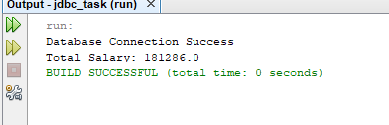

1. **sumSalary(int deptno):**

/*

* To change this license header, choose License Headers in Project Properties.

* To change this template file, choose Tools | Templates

* and open the template in the editor.

*/

package com.task.dao;

import com.task.bean.EmpBean;

import com.task.utility.ConnectionPool;

import java.sql.Connection;

import java.sql.ResultSet;

import java.sql.SQLException;

import java.sql.Statement;

import java.util.ArrayList;

import java.util.logging.Level;

import java.util.logging.Logger;

/**

*

* @author manis

*/

public class EmpDAo {

static Connection conn;

public double SumSalary(int deptno) {

conn = ConnectionPool.connectDB();

double totalSalary = 0;

String sql = "SELECT SUM(sal) as total from emp where deptno = '"+deptno+"'";

try {

Statement stmt = conn.createStatement();

ResultSet rs = stmt.executeQuery(sql);

if (rs.next()) {

totalSalary = rs.getFloat("total"); // Fetch sum(sal)

}

conn.close();

} catch (SQLException ex) {

Logger.getLogger(EmpDAo.class.getName()).log(Level.SEVERE, null, ex);

}

return totalSalary;

}

public static void main(String[] args) {

EmpDAo ed = new EmpDAo();

double totalSal = ed.SumSalary(10);

System.out.println("Total Salary: " + totalSal);

}

}

**.Output:**

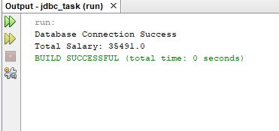

1. **sumSalaryByJob(String job):**

/*

* To change this license header, choose License Headers in Project Properties.

* To change this template file, choose Tools | Templates

* and open the template in the editor.

*/

package com.task.dao;

import com.task.bean.EmpBean;

import com.task.utility.ConnectionPool;

import java.sql.Connection;

import java.sql.ResultSet;

import java.sql.SQLException;

import java.sql.Statement;

import java.util.ArrayList;

import java.util.logging.Level;

import java.util.logging.Logger;

/**

*

* @author manis

*/

public class EmpDAo {

static Connection conn;

public double SumSalaryByJob(String job) {

conn = ConnectionPool.connectDB();

double totalSalary = 0;

String sql = "SELECT SUM(sal) as total from emp where job = '"+job+"'";

try {

Statement stmt = conn.createStatement();

ResultSet rs = stmt.executeQuery(sql);

if (rs.next()) {

totalSalary = rs.getFloat("total"); // Fetch sum(sal)

}

conn.close();

} catch (SQLException ex) {

Logger.getLogger(EmpDAo.class.getName()).log(Level.SEVERE, null, ex);

}

return totalSalary;

}

public static void main(String[] args) {

EmpDAo ed = new EmpDAo();

double totalSal = ed.SumSalaryByJob("CLERK");

System.out.println("Total Salary: " + totalSal);

}

}

**.Output:**

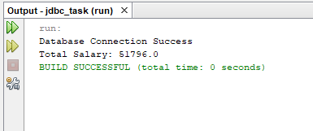

1. **Average Salary:**

/*

* To change this license header, choose License Headers in Project Properties.

* To change this template file, choose Tools | Templates

* and open the template in the editor.

*/

package com.task.dao;

import com.task.bean.EmpBean;

import com.task.utility.ConnectionPool;

import java.sql.Connection;

import java.sql.ResultSet;

import java.sql.SQLException;

import java.sql.Statement;

import java.util.ArrayList;

import java.util.logging.Level;

import java.util.logging.Logger;

/**

*

* @author manis

*/

public class EmpDAo {

static Connection conn;

public double AvgSalary() {

conn = ConnectionPool.connectDB();

float AvgSalary = 0;

String sql = "SELECT AVG(sal) AS total FROM emp";

try {

Statement stmt = conn.createStatement();

ResultSet rs = stmt.executeQuery(sql);

if (rs.next()) {

AvgSalary = rs.getFloat("total"); // Fetch sum(sal)

}

conn.close();

} catch (SQLException ex) {

Logger.getLogger(EmpDAo.class.getName()).log(Level.SEVERE, null, ex);

}

return AvgSalary;

}

public static void main(String[] args) {

EmpDAo ed = new EmpDAo();

double totalSal = ed.AvgSalary();

System.out.println("Average sal : " + totalSal);

}

}

**.Output:**

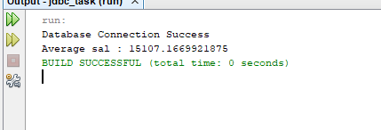

**17.Find Max Salary:**

/*

* To change this license header, choose License Headers in Project Properties.

* To change this template file, choose Tools | Templates

* and open the template in the editor.

*/

package com.task.dao;

import com.task.bean.EmpBean;

import com.task.utility.ConnectionPool;

import java.sql.Connection;

import java.sql.ResultSet;

import java.sql.SQLException;

import java.sql.Statement;

import java.util.ArrayList;

import java.util.logging.Level;

import java.util.logging.Logger;

/**

*

* @author manis

*/

public class EmpDAo {

static Connection conn;

public double FindMaxSalary() {

conn = ConnectionPool.connectDB();

double totalSalary = 0;

String sql = "SELECT MAX(sal) as max_salary from emp";

try {

Statement stmt = conn.createStatement();

ResultSet rs = stmt.executeQuery(sql);

if (rs.next()) { // Iterate through multiple rows

double maxSalary = rs.getDouble("max_salary");

System.out.println("HighestSalary: "+ maxSalary);

}

conn.close();

} catch (SQLException ex) {

Logger.getLogger(EmpDAo.class.getName()).log(Level.SEVERE, null, ex);

}

return totalSalary;

}

public static void main(String[] args) {

EmpDAo ed = new EmpDAo();

ed.FindMaxSalary();

}

}

**.Output:**

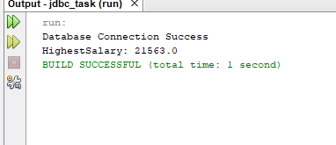

1. **Find Lowest Salary:**

/*

* To change this license header, choose License Headers in Project Properties.

* To change this template file, choose Tools | Templates

* and open the template in the editor.

*/

package com.task.dao;

import com.task.bean.EmpBean;

import com.task.utility.ConnectionPool;

import java.sql.Connection;

import java.sql.ResultSet;

import java.sql.SQLException;

import java.sql.Statement;

import java.util.ArrayList;

import java.util.logging.Level;

import java.util.logging.Logger;

/**

*

* @author manis

*/

public class EmpDAo {

static Connection conn;

public double FindLowSalary() {

conn = ConnectionPool.connectDB();

double totalSalary = 0;

String sql = "SELECT MIN(sal) as min_salary from emp";

try {

Statement stmt = conn.createStatement();

ResultSet rs = stmt.executeQuery(sql);

if (rs.next()) { // Iterate through multiple rows

double LowSalary = rs.getDouble("min_salary");

System.out.println("LowestSalary: "+ LowSalary);

}

conn.close();

} catch (SQLException ex) {

Logger.getLogger(EmpDAo.class.getName()).log(Level.SEVERE, null, ex);

}

return totalSalary;

}

public static void main(String[] args) {

EmpDAo ed = new EmpDAo();

ed.FindLowSalary();

}

}

**.Output:**

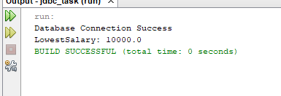

**21.Count Number of Employee:**

/*

* To change this license header, choose License Headers in Project Properties.

* To change this template file, choose Tools | Templates

* and open the template in the editor.

*/

package com.task.dao;

import com.task.bean.EmpBean;

import com.task.utility.ConnectionPool;

import java.sql.Connection;

import java.sql.ResultSet;

import java.sql.SQLException;

import java.sql.Statement;

import java.util.ArrayList;

import java.util.logging.Level;

import java.util.logging.Logger;

/**

*

* @author manis

*/

public class EmpDAo {

static Connection conn;

public void CountEmp() {

conn = ConnectionPool.connectDB();

String sql = "select count(*) as cnt from emp";

try {

Statement stmt = conn.createStatement();

ResultSet rs = stmt.executeQuery(sql);

if (rs.next()) { // Iterate through multiple rows

int cnt = rs.getInt("cnt");

System.out.println("Count number of emp: "+ cnt);

}

conn.close();

} catch (SQLException ex) {

Logger.getLogger(EmpDAo.class.getName()).log(Level.SEVERE, null, ex);

}

}

public static void main(String[] args) {

EmpDAo ed = new EmpDAo();

ed.CountEmp();

}

}

**.Output:**

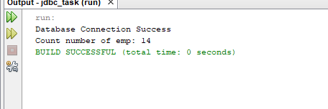

1. **countEmpByJob(String job):**

/*

* To change this license header, choose License Headers in Project Properties.

* To change this template file, choose Tools | Templates

* and open the template in the editor.

*/

package com.task.dao;

import com.task.bean.EmpBean;

import com.task.utility.ConnectionPool;

import java.sql.Connection;

import java.sql.ResultSet;

import java.sql.SQLException;

import java.sql.Statement;

import java.util.ArrayList;

import java.util.logging.Level;

import java.util.logging.Logger;

/**

*

* @author manis

*/

public class EmpDAo {

static Connection conn;

public double countEmpByJob(String job) {

conn = ConnectionPool.connectDB();

double totalSalary = 0;

String sql = "select count(*) as jb from emp where job = '"+job+"'";

try {

Statement stmt = conn.createStatement();

ResultSet rs = stmt.executeQuery(sql);

while (rs.next()) { // Iterate through multiple rows

String cnt = rs.getString("jb");

// double avgSalary = rs.getDouble("avg_salary");

System.out.println( cnt);

}

conn.close();

} catch (SQLException ex) {

Logger.getLogger(EmpDAo.class.getName()).log(Level.SEVERE, null, ex);

}

return totalSalary;

}

public static void main(String[] args) {

EmpDAo ed = new EmpDAo();

ed.countEmpByJob("CLERK");

}

}

**.Output:**

